Thorndike's Experiment
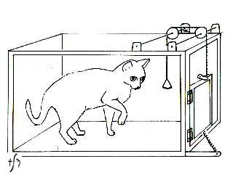Thorndike's cat experiment. Image borrowed from: History of Psychology: American Behaviorism. Click on the picture to follow the link.
At the very end of the 19th century Thorndike, one of most commonly mentioned connectionists and an important learning theorist, performed experiments first on chickens and later on cats and dogs to analyze how animals learn.
In one experiment, he placed a hungry cat inside a puzzle box, which had a mechanism that would open the doors of the box every time a string would be pulled or a button pushed. After each successful escape out of the box by opening its doors, the cat needed a bit less time to repeat the required process next time. The desired behavior slowly increased.
Based on this experiment Thorndike concluded that learning is incremental and not insightful, since the learning of the correct response occurred only through repetition trial and error forming of associations between situation and response. Established S-R connections are the key aspect of knowledge.

