Component Display Theory

General
Component display theory is one of the cognitivist theories of instructional design introduced by Dave Merrill in the 1980s, whose original intention was to separate content from instructional strategy. In his own words, “Component Display Theory was an attempt to identify the components from which instructional strategies could be constructed.”1) Aside from identifying those components, Merrill suggested their usage in order to create successful instructions.

What is component display theory?
Influenced by Robert Gagne's theory of conditions of learning, Merrill agreed that different learning outcomes require different learning strategies, and his idea therefore was to suggest learning strategies according to target content and performance. Merrill suggested four different categories of content:
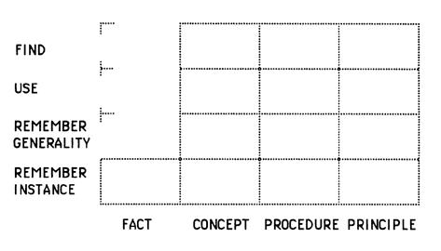The Performance-Content Matrix. Source: Merrill, M. David. The Descriptive Component Display Theory. In Merrill, M. David, and David Twitchell. Instructional design theory, p. 112. Educational Technology, 1994. Click on the picture to follow the link.
- facts (“arbitrarily associated pieces of information”)
- concepts (“a set of objects, events, or symbols with shared common characteristics”),
- procedures (“an ordered sequence of steps necessary for the learner to accomplish some goal”), and
- principles (“or predictions of why things happen in the world”)2),
and three different categories of desired performance:
- remember (“search memory in order to reproduce or recognize some item of information previously known”),
  - generality (“a statement of a definition, principle or the steps in a procedure”)
  - instance (“specific illustration of an object, symbol, event, process or procedure”)
- use (“apply a generality to a specific case”), and
- find (“derive or invent a new abstraction”)3).
The performance-content matrix is used to identify learning objectives. Each of the matrix fields presents one possible arrangement of learning content and target performance. For example, objective to teach a student to memorize facts and dates reffering to First World War refers to the remember instance/facts field in the matrix, and objective to teach a student to identify humanist ideas in paintings of renaissance artists refers to the find/concept field.
Each so defined learning objective is further characterized by three components: conditions, behavior and criterion. Merrill constructed tables addressing these components for each of the mentioned matrix fields (Still in the mentioned tables he did not distinguish between two types of remembering mentioned above). An example row from the table3) looks like this:
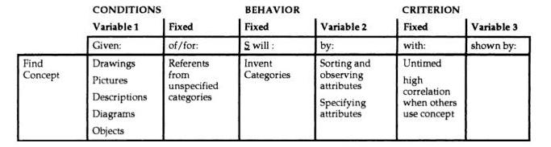Specification of objectives for performance-content matrix. Image borrowed from: Merrill, M. David. The Descriptive Component Display Theory. In Merrill, M. David, and David Twitchell. Instructional design theory, p. 111. Educational Technology, 1994. Click on the picture to follow the link.
An example of interpretation is following:
- (Under conditions when/If) given pictures/drawings (column 1)
- of/referring to unspecified categories (column 2),
- student will (behave to) invent categories (column 3)
- by observing, specifying and sorting attributes (column 4),
- with no time limits, but high correlation when others use concept (column 5),
- which will be shown by -.

Now when the learning objective is fully defined, a learning presentation should be designed. According to Merrill, all cognitive matter can and should be presented as a sequence of discrete presentations composed out of primary and secondary presentation forms. Primary presentation forms are:
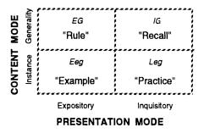Primary Presentation Forms. Source: Merrill, M. David. The Descriptive Component Display Theory. In Merrill, M. David, and David Twitchell. Instructional design theory, p. 112. Educational Technology, 1994. Click on the picture to follow the link.
- expository4) presentation of a generality (rules, EG)
- expository presentation of instances (examples, Eeg)
- inquisitory5) generalities (recall, IG)
- inquisitory instances (practice, Leg)
Merrill's secondary presentation forms, added in order to enhance learning, facilitate information processing and add context, include prerequisites objectives, helps, mnemonics and feedback.
A successful instructional design should include primary and secondary presentation forms. Fundamental elements of all four types of primary presentation forms based on the content type which should be learned are suggested by Merrill6). He also describes them in more details and recommends them on practical examples of a simple computer application for learning. While doing that, he keeps in mind that “one of the primary functions of instruction is to promote and guide active mental processing on the part of the student” and that the learner should also be provided with a number of examples he wants.

Criticisms
A number of limitations of component display theory were described by Merrill himself7):
- Content analysis focuses on components, rather than integrated wholes. Each phase of instructional development is performed independently of other phases.
- It does not really address the issues of knowledge acquisition.
- The resulting instruction is often passive and teaches components but not integrated knowledge and skills.
- An instructional designer must build every presentation from fundamental components.

Keywords and most important names

Bibliography
Learning and ID: Cognitive Apprenticeship and Component Display Theory. Learning and Instructional Design Wiki. Retrieved: 10. March 2011.
Ho, Wenyi. Merrill's Component Display Theory (CDT). Penn State University. Retrieved: 10. March 2011.
Merrill, M. David. The Descriptive Component Display Theory. In Merrill, M. David, and David Twitchell. Instructional design theory. Educational Technology, 1994.
“Component display theory - eLearning snippets.”.

Read more
Reigeluth, Charles M. Instructional-Design Theories and models: An Overview of their Current Status. Lawrence Erlbaum Associates, Publishers, Hillsdale, New Jersey London, 1983.

1) Merrill, M. D. “Instructional transaction theory (ITT): Instructional design based on knowledge objects.” Instructional-design theories and models: A new paradigm of instructional theory 2: 397–424. 1999.
2) Merrill, M. David. The Descriptive Component Display Theory. In Merrill, M. David, and David Twitchell. Instructional design theory, p. 112. Educational Technology, 1994.
3) Merrill, M. David. The Descriptive Component Display Theory. In Merrill, M. David, and David Twitchell. Instructional design theory, p. 111. Educational Technology, 1994.
4) The term expository can here roughly be explained as talk, present, or show.
5) The term inquisitory can here roughly be explained as question, ask, or require practice.
6) See: Merrill, M. David. The Descriptive Component Display Theory. In Merrill, M. David, and David Twitchell. Instructional design theory, p. 123. Educational Technology, 1994.
7) Merrill, M. David, Zhongmin Li, & Jones, Mark K. Second generation instructional design (ID2). EDUCATIONAL TECHNOLOGY 30: p7-14. 1990.

