Operant conditioning

General
Operant conditioning, sometimes also known as Skinnerian conditioning or radical behaviorism is a behaviorist learning approach similar to classical conditioning, mostly influenced by early theoretical and experimental works of American psychologist Burrhus Frederic Skinner from the 1950s. Main difference between those two theories is that classical conditioning modifies only reflex reactions and operant conditioning shapes new behavior.

What is operant conditioning?
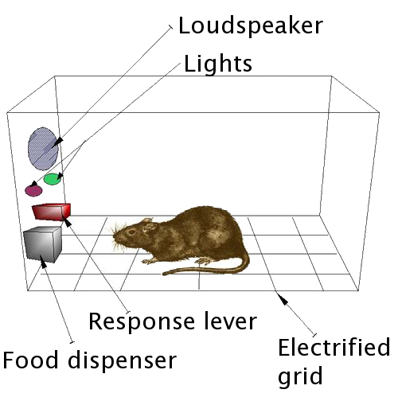Skinner's box. Image borrowed from: WikiMedia.org. Click on the picture to follow the link.
The most famous experiment considering operant learning is Skinner box, also known as operant conditioning chamber. In one such experiment Skinner demonstrated the principles of operant conditioning and behavior shaping on a rat using reinforcement in terms of food. A starved rat was put in a box, in which pressing a small lever would release some food. The rat soon learned that pressing the lever would get him some food.
In another experiment, two lights (red and green) were introduced into the box and the rat would only get the food if one of them was on. The rat soon learned to discriminate between the lights, and stopped or reduced pressing the lever when the “wrong” light was on.
Unlike Pavlovian conditioning, where an existing behavior (salivating for food) is shaped by associating it with a new stimulus (sound of a bell), operant conditioning is the rewarding of an act that approaches a new desired behavior, but can also be the opposite: punishing undesirable behavior (negative reinforcement).1)
After accidentally running short on rat food once, Skinner also started observing effects of different schedules of reinforcement1):
- continuous - reinforcement occurs after every displayed behavior,
- fixed ratio - reinforcement occurs every X trials,
- fixed interval schedules - reinforcement occurs if desired behavior is shown within the specific time interval, or
- variable schedules - number of required behavior displays in order to receive reinforcement is different every time.
An interesting observation he made was that if fixed interval is used, rats managed to find a “rhythm” in displaying of behavior, which was never the case in variable schedules. Variable schedules, surprisingly, have also shown to be very resistant to extinction. The gambling addiction offers another example for this: although reinforcement comes rarely, one can never be sure if it will or won't come the next time so he gives another try.
Operant conditioning can also be used to shape more complex behaviors by starting from an idea similar to the intended behavior and after it is learned slowly shaping it until it becomes exactly what was desired. An example of this is how Skinner and his students managed to teach pigeons to bowl.1)
Some of his ideas Skinner incorporated in his book “Walden II”, about a behavior control based utopian society. He is also remembered for claiming that if his house was on fire, he would rather save his books than his children, since his writings could make greater contributions than his genes.1)

What is the practical meaning of operant conditioning?
There are many examples of operant conditioning in everyday use. The act of completing homework in order to get a reward from a teacher, or finishing projects to receive praise or promotions from the employer is a form of operant conditioning2). In these examples, the increased probability of certain behavior is the result of possibility of rewards.
Oppositely, operant conditioning can also be used to decrease probability of certain behavior by use of punishment (averse stimulus). For example, children in classroom may be told they will have to sit in the back of the classroom if they talk out of turn2). The possibility of punishment may decrease the probability of unwanted behaviors.

Criticisms
Criticisms of operant conditioning are similar to criticisms in general. Operant conditioning
- ignores cognitive processes,
- assumes learning occurs only through reinforcement which is not true,
- and overlooks genetic predispositions and species-specific behavior patterns which can interfere with it.

Keywords and most important names
- Operant conditioning, Skinnerian conditioning, radical behaviorism, Skinner box, operant conditioning chamber, schedules of reinforcement
- Burrhus Skinner

Bibliography
Boeree, G. Personality theories: B. F. Skinner. Retrieved February 22, 2011.
Blackman, Derek E. Operant conditioning: an experimental analysis of behaviour. Routledge, 1974.

Read more
Skinner, Burrhus F. About behaviorism. Vintage Books, 1974.
Skinner, B. F. "Superstition" in the Pigeon. Journal of Experimental Psychology #38, p168-172. 1947.
Peterson, G. B. A day of great illumination: BF Skinner's discovery of shaping. Journal of the Experimental Analysis of Behavior 82, no. 3, p317-328. 2004.
Wolf, M., Risley, T., Johnston, M., Harris, F. and Allen, E. Application of operant conditioning procedures to the behavior problems of an autistic child: a follow-up and extension. Behaviour Research and Therapy 5, no. 2, p103-111. May 1967.
Levene, Howard I., Engel, Bernard T. and Pearson, John A. Differential Operant Conditioning of Heart Rate. Psychosom Med 30, no. 6, p837-845. November 1, 1968.

1) Boeree, George. F. B. Skinner. Personality Theories.
2) Cherry, K. Introduction to Operant Conditioning. About.com Psychology.

